**Project Based Learning Report**

on

**COMPUTER NETWORKING PRACTICUM**

Submitted

In fulfilment

For the award of the degree of

**BSC. INFORMATION TECHNOLOGY**

in Department of IT



**Submitted by:**

Tony Ndereva Maluki

SC211/0709/2018

**AUGUST,2021**

## MURANGA UNIVERSITY OF TECHNOLOGY

College of Engineering & Technology

Tony Ndereva Maluki

**DECLARATION AND APPROVAL**

I Maluki Maluki Tony Ndereva, declare that this report is my original work and has not been presented or forwarded to any other additional party for any kind of award or any kind of qualification

NAME: ________________________________-

SIGNATURE: ___________________________

DATE: _______________________________

I confirm that this(my) proposal has been exclusively submitted to Lecturer _________________________under the school of computing and IT in Murang’a University of Technology

**INTRODUCTION:**

* My project, I was to come up, design, and configure a network organisation with 3 branches each with branch with a 3 - floor network design and all the units/computers and end – devices should be able to communicate to each other and be able to efficiently deliver messages and information inside a single branch as well as across branches.
* I came up with a virtual Sacco organisation company. The work of a Sacco is to store customer’s money which in turn the customers money gains interest during the period the money is in the Sacco.
* The customer can take loans up to 100% the amount banked

**SOFTWARE USED:**

* With this project, I resulted to be using Cisco Packet Tracer Cisco Network company which offers a wide range of features such as:

1. Design and draw of floor buildings
2. Availability of various end-user devices such as computers, tablets, smartphones
3. Availability of various network devices such as routers, switches, hubs etc

1. Availability of various connectivity tools such as RJ45 connectors, (cross-over, straight), fibre optic cables, etc
2. Availability of simulation and Realtime feature

**PROJECT-BUILDING:**

- I started by designing my organisation by drawing on a piece of paper various network topologies that would best fit and that would be of practically less cost but yet effective

- After choosing the best design, I started working on the organisation branch 1 whereby I drew the organisations floors and design of various offices like the:

i) manager’s office, where the manager will be working from

ii) the IT department where the IT employees will be working together to ensure that everything is working correctly in the company,

iii) the server room to house the company servers,

iv)the reception office whereby the customers would be ushered in to the company and any kind of assistance to be offered there.,

iv)the human resource office where anything with employers and salaries are dealt with

v)the conference room where stakeholders will be holding virtual and physical meetings from

vi)the account’s office where all financial queries, financial information for customer is found

vii)various teller whereby customers will be served

viii)management board office where stakeholders will be doing their duties from

ix)the insurance office where insurance services would be offered

* After completing the drawing of the network floor design, I allocated various end devices such as:

1. Desktop computers
2. Laptop computers
3. Printers
4. IP phones
5. Smartphones

* After that I went to the next step to include communicating network devices such as the switches, routers and hubs etc..
* Next I used various connecting means and wires such as :

1. Console cables
2. Copper straight through
3. Copper cross-over
4. Fibre optic
5. Coaxial cables

--🡪to connect the devices together. I connected the computers, laptops and printers to relevant sub switches by use of copper straight through cable and each switch I would subsequently connect all switches together through a network floor switch and by use of copper cross over cable. All network floor switches I joined them together by use of a main switch by use of copper cross over cables

-🡪when I finished all the wiring, next I went to work on branch 2 and 3, the same process until all were done.

🡪Then I went back to branch 1 to setup IP addresses in order to establish communication.

-🡪 I resulted to using a DHCP SERVER to automatically assign IP addresses to clients instead of using static IP addresses which would be a tedious job on configuring close to around 100 addresses each a static IP address manually

-🡪for the DHCP servers, I created a DHCP service pool which generates IP addresses and default getaway address to all devices

-🡪I also included a DNS server which would store all IP addresses of websites

-🡪I also included a web server which would host the company’s website, “FAULU-SACCO.COM”

-🡪the same process is repeated for branch 2 and 3

--🡪 after finishing for branch 2 and 3, I included a main default router 2911 which would enable communication between branch 1, 2 and 3 and vice versa,

🡪 I included a unique default getaway address for each branch that the users would use to communicate across the network

**SCREENSHOTS OF THE WORK:**

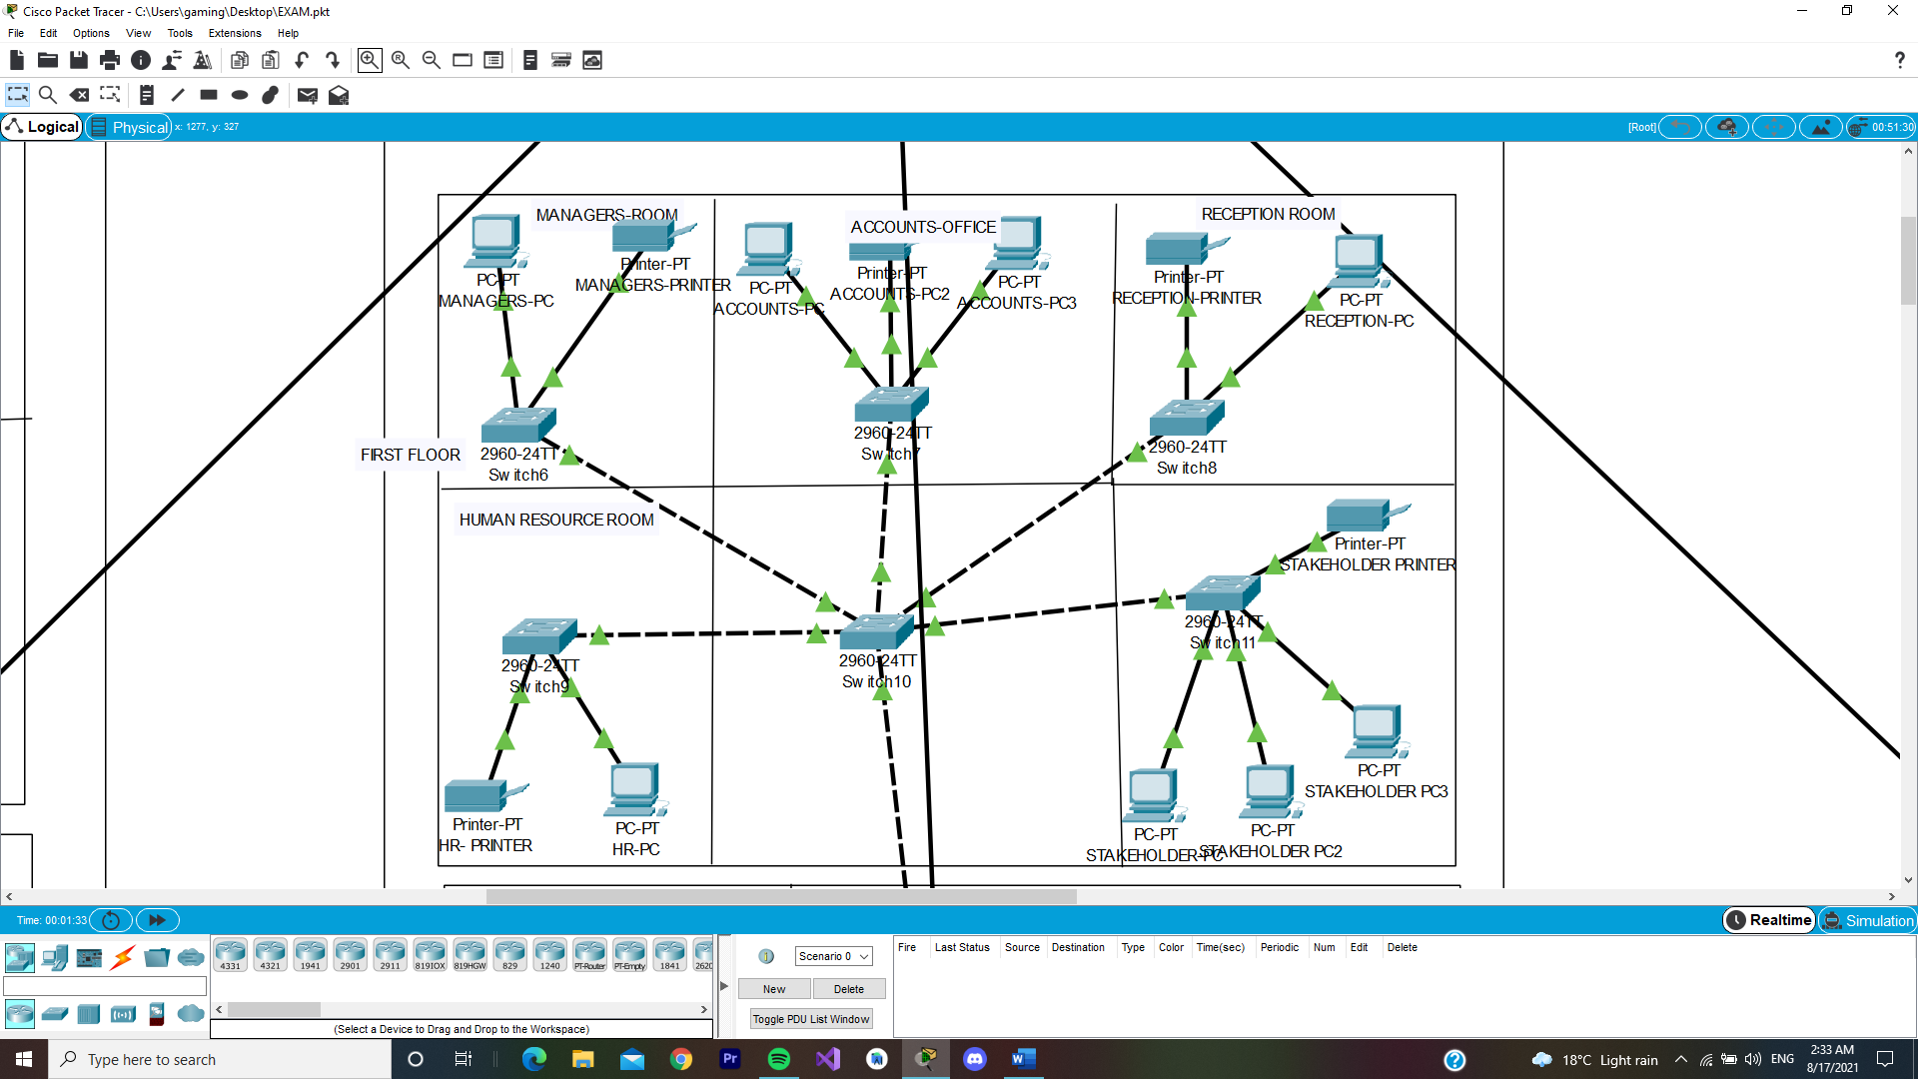

**FLOOR 1 BRANCH 2 TOPOLOGY**

**-------------------------------------------------------------------------------------**

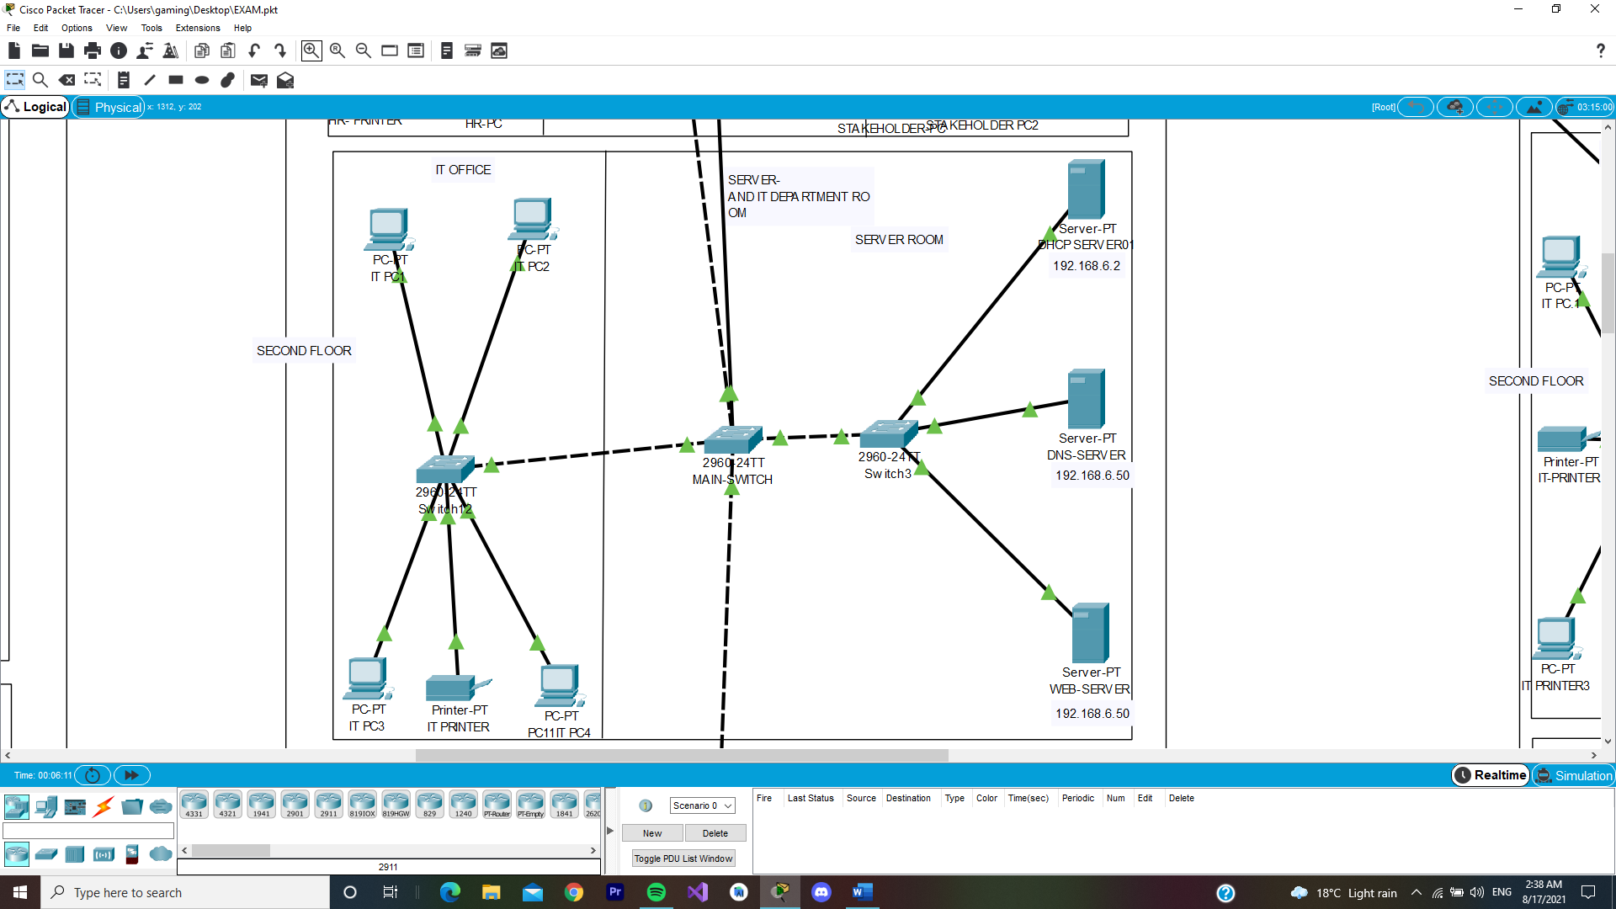

**FLOOR 2 BRANCH 2 TOPOLOGY**

**---------------------------------------------------------------------------------**

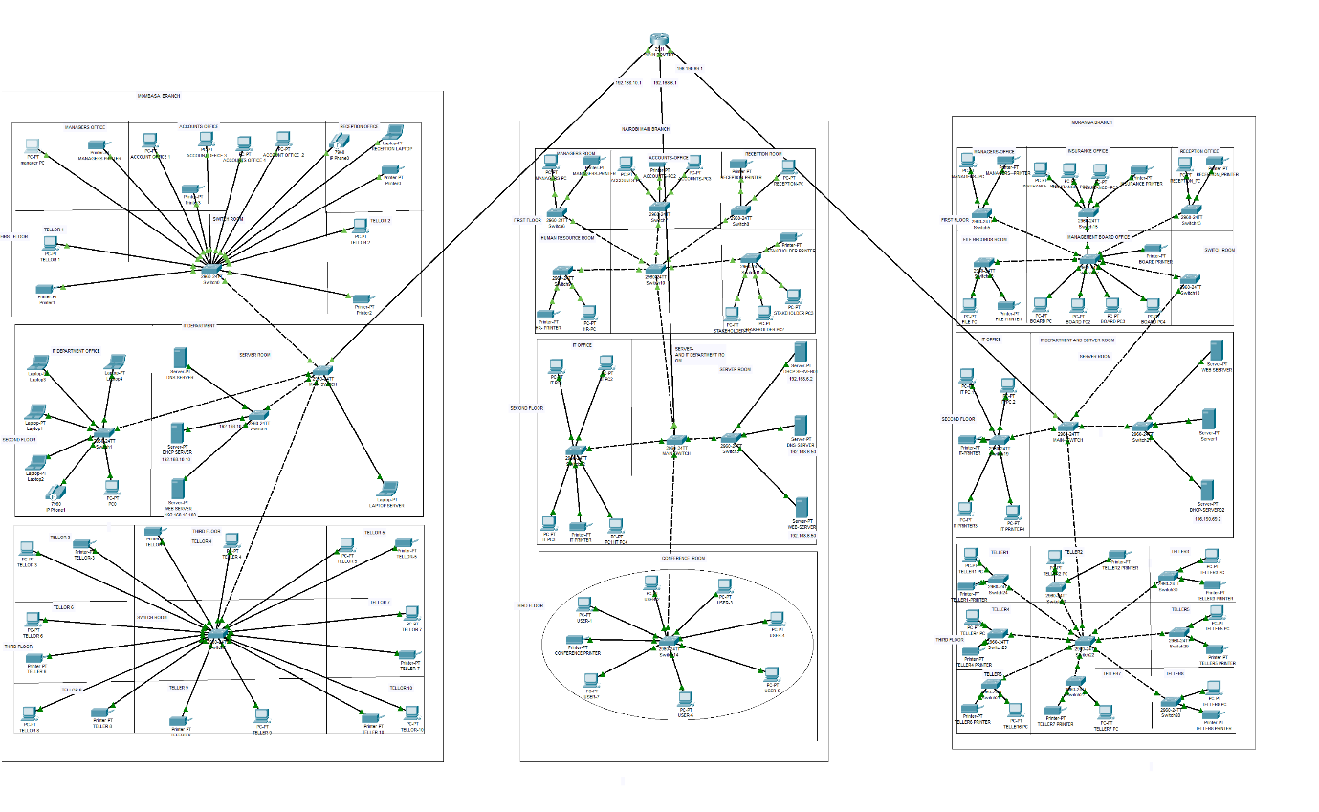

**WHOLE ORGANISATION NETWORK TOPOLOGY**

---------------------------------------------------------------------------------

CONCLUSION:

After the final configuration, all the devices worked and are able to successfully send packet messages from one device to any other device of choice in the network, be it the teller computers, managers desktop to IT department, name it. All are working

-Also, I conclude that the cisco packet tracer app is a good app for simulation , testing and estimation of a real world network configuration which reduces time of planning , design and cost of designing networks